Drieam

Edita Pronckutė

Semester 8

28/02/2023

Design Document



# E-portfolios

Most of the competitor LMSs or eportfolios are not freely accessible to view, however, some of them offer a demo to try out. Below are some of the snippets of the similar applications the focus is on the aggregated data display and options.

**EPASS** was started in 2008 by the Department of Educational Development and Research of Maastricht University. It offers an eportfolio for Health, Medicine and Life Sciences studies.

Figure 1. Epass portfolio for medical students.

**Educator** is a student information system for secondary, higher and private education. The Leermeter is a part of the Educator though can be used as standalone too. It is a great progress tracking tool that aids in assessments and reviews.

Figure 2. Educator Leermeter functionality.

**Mahara** is a modular eportfolio tool first established in 2006 in New Zealand. It is a stand-alone system where students can upload evidence of their work to showcase for assessment and reviews with multiple people.

Figure 3. Mahara e-portfolio web app.

**Moodle** is a free open source learning platform designed to provide educators, administrators and learners with a system to create personalized learning environments. Moodle is an LMS and Portflow can be integrated to work with it as it does not have an explicit portfolio functionality.

Figure 4. Moodle LMS demo where student can submit only what is expected.

Paragin offers a **MijnPortfolio** product among other things that gives students and professionals to showcase their work for performance assessment, potential jobs and demos. It does look rather like a resume.

Figure 5. MijnPortfolio by Paragin example

**Sakai** is an open source LMS that offers eportfolio functionality among other things. It is developed by educators for various educational institutions. There is an extensive documentation on how to set up and use the LMS whether as an institution or as an individual.

Figure 6. Sakai dark mode resource management page

**Simulise** is a digital portfolio, students can store and beautifully display all types of materials. In addition, it offers many opportunities to demonstrate and develop competencies and skills. This eportfolio is the quite similar to Portflow is several features such as feedback, parts of the portfolio can be made public as a showcase, skills development, rubric scales etc.

Figure 7. Simulise portfolio example

## Conclusion

The students are always able to upload files (word processing documents, spreadsheets, slide presentations, audio and videos, web links). They can then organize these files and links into folders and subfolders making it easier to locate and access items. It is also common to allow users to upload multiple files using the Drag and Drop interface.

Thus, various document types are uploaded to the digital portfolios, the files are typically grouped in collections (folders, sections, thema’s etc.), therefore a good way to display (list) the contents is per their collection. There is also data available for each file, such as name, type, size, date-created, collections, semester and tags. It would be a good idea to offer filtering based on these parameters next to a name search option.

# File Managers

In addition to existing e-portfolios and LMSs the student reviewed file managers as the Evidence section is about the convenient aggregated data management and display.

It is worth to look into mobile solutions too as they tend to be more compact and neater than the file managers for computers. Below are the popular android file management tools. Left to right: Google Drive, Files (for internal storage by google) and Files (default Android file manager).

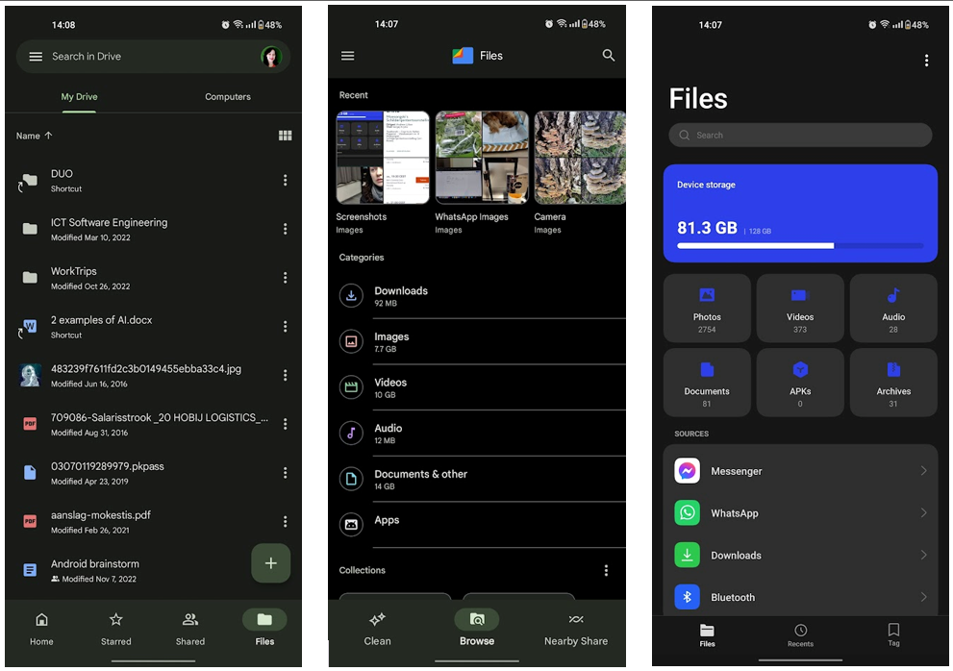

Figure 8. Examples of file manager apps on mobile.

**Opus12** is a replacement for a default file explorer for windows. It offers way more functionality and features.

Figure 9. Opus12 file manager for windows.

**Windows File Manager** is a remake of the file manager of older windows version of 1990s. It has been brought up to life since 2019 and is applicable to win10+ offering original and some added features.

Figure 10. Windows file manager example.

**Xplorer2** is another file manager for windows OS offering a large variety of features including a custom categorization.

Figure 11. Xplorer2 file manager with a variety of features.

## Conclusion

File managers seem to offer many features that would be very overwhelming for the Evidence section, however, some ideas are worth exploring:

* File map to show where the file is within the rest,
* Viewing by (list, icons, info),
* Sorting by (size, name, date),
* Filtering by (date, name, collection, type),
* Preview section
* Hovering over the file for information or display details in a separate section.

These are common through all file managers offered one way or the other and it can really help in managing aggregated data.

**Portfolio Evidence Designs**

**Option A:** does not look neat, the drop downs add clutter and seems like an unfinished form.

**Option B:** Looks tidier, however it is not clear how to add or link new collections and goals. It could use a “add” or “+” buttons.

**Option C:** has it all and looks clear and functional, however in the end all these designs are still basically lists and not a dashboard, lacking sorting, counting and preview features among other useful tools.

# SUMMARY

Some portfolios lack proper data aggregation management tools (meaning students lack control over the content once it is uploaded). However, it is quite common to offer default sorting by different evidence types (pptx, image, text file, video etc.). Most of the examples offer quick upload or moving options via drag & drop.

Exploring file management solutions offered more insights as not every eportfolio applications even allows students much freedom to manage their own content as Portflow. In addition, most of them is not accessible for an outsider to review too.

Sources

<https://www.pagerduty.com/resources/learn/what-is-data-aggregation/>

<https://www.ibm.com/docs/en/qsip/7.4?topic=tasks-managing-aggregated-data-views>

<https://www.epass.eu/en/about-epass/mission-en-vision/>

<https://www.educator.eu/leermeter/>

<https://mahara.org/>

<https://moodle.org/>

<https://www.paragin.nl/mijnportfolio/>

<https://sakai.screenstepslive.com/s/sakai_help>

<https://www.sakailms.org/>

<https://www.simulise.com/>

<https://www.gpsoft.com.au/>

<https://www.zabkat.com/sshots.htm>